How do maternal characteristics and perinatal conditions influence survival outcomes in multiple births?

Max Vo, Frank Hsu, Suning Zhao, Jolly Lin, Mert Cumhur
¹University of California, Los Angeles, FSPH, MDSH

I. INTRODUCTION

Multiple gestation pregnancies, including twins, triplets, and quadruplets carry substantially higher risks compared to singleton pregnancies (Fair Oaks Women’s Health, 2024). These pregnancies are often associated with higher rates of maternal complications, and elevated infant mortality, making them an important perinatal research (Brancazio, 2024).

In this study, we first present descriptive summaries of birth outcomes stratified by plurality (twin, triplet or quadruplet) and matched-birth outcomes. Furthermore, we briefly explore the distribution of variables of interest by plurality. We then investigate whether key variables—such as maternal education and nativity, which may exhibit greater stochastic variability, alongside factors like abnormal delivery conditions, infection status, and maternal health—can be used to model survival outcomes in multiple births. Using logistic regression analysis, we aim to identify maternal and perinatal factors that contribute to differences in survival outcomes among multiple gestations.

II. METHODS & MATERIALS

A. Data Set
The data used in this study come from the Matched Multiple Birth and Fetal Death Data Set, 2016–2020, developed by the National Center for Health Statistics (NCHS) as part of the National Vital Statistics System (NVSS). This publicly available dataset enables analysis of birth outcomes—including survival, infant death, and fetal death—among multiple deliveries (twins, triplets, and quadruplets). Records were drawn from U.S. vital statistics and include live births and fetal deaths occurring at 20 or more completed weeks of gestation among U.S. residents from 2016 through 2020.

The dataset contains 641,934 records, comprising 626,541 live births, 8,200 fetal deaths, and 7,193 infant deaths. Members of the same multiple delivery are linked using a unique identifier (MULTID), enabling analysis at the multiple-birth set level. Matching was performed by NCHS using key identifiers including plurality, state and county of occurrence, facility ID, and the mother’s date of birth. Quintuplets and higher-order multiples were excluded in accordance with NCHS confidentiality policies.

The Dataset’s documentation and codebook are available via : https://www.cdc.gov/nchs/data_
access/vitalstatsonline.htm.

B. Study Population
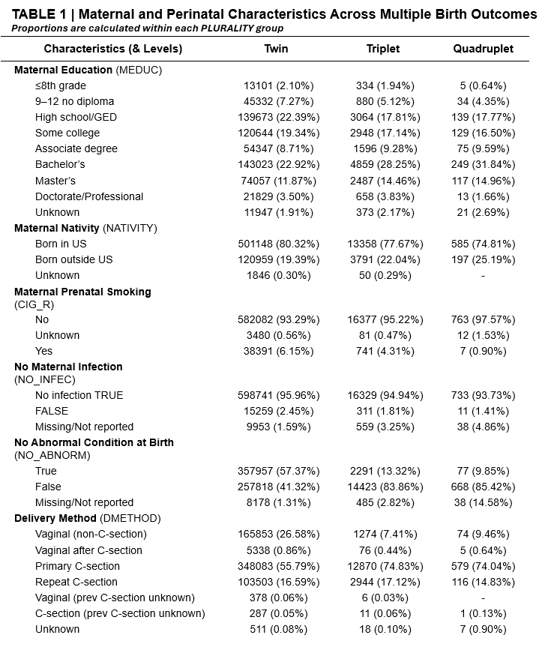
The final variables of interest, which we selected to address our question were Maternal Education, Maternal Nativity, Maternal Infection during pregnancy, abnormal conditions at birth, and delivery method.

Table 1 presents a cross-tabulation of categorical variables, showing both counts and within-group proportions. It provides a descriptive summary of maternal and perinatal characteristics across multiple birth outcomes, stratified by plurality (twins, triplets, quadruplets). For each characteristic, the table reports the frequency (number of individuals) and the row proportion (%) within each plurality group.

Overall, this table allows for comparison of maternal and perinatal factors across different plurality levels, highlighting which characteristics are more or less common among twins, triplets, and quadruplets.

Figure 1 - Data Hierarchy Tree

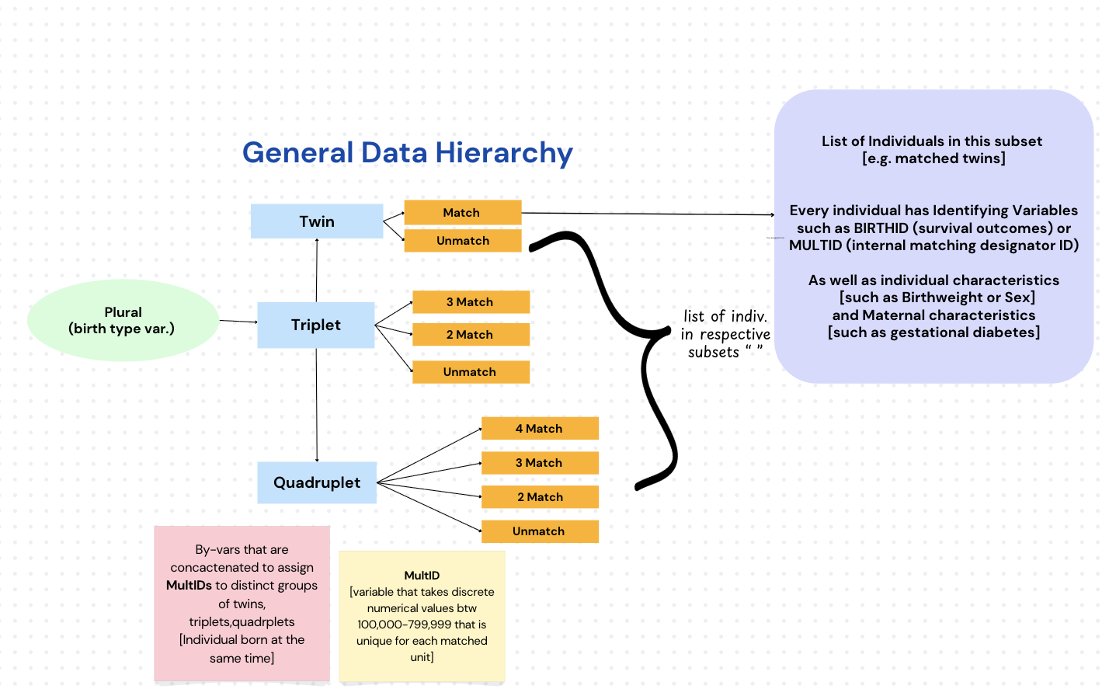

Figure 1 illustrates the overall structure and hierarchy of the matched dataset. Note that this flowchart represents the original data organization and does not reflect the specific structure used for the simple logistic analysis discussed in Section C.

C. Statistical Methods
Analyses were conducted to summarize and explore birth outcomes among multiple births. Descriptive statistics characterized the study population across categorical variables, as most numerical variables had been recoded into categorical form by the NCHS prior to public release.

An initial mixed-effects logistic regression model was considered to account for the matched structure of the data (defined by MultID), but model complexity limited feasibility in SAS. Therefore, we decided to utilize separate binary logistic regression models that were fitted for each plurality group (twins, triplets, and quadruplets).

For each model, the binary outcome represented whether all infants in a multiple-birth group survived (e.g., “2 Survivors” for twins, “3 Survivors” for triplets) versus any other birth outcome–with alternative outcomes shown in Tables 1A-C being merged. Predictors included maternal education, maternal nativity, prenatal smoking, maternal infection status, abnormal delivery conditions, and delivery method.

Categorical predictors were coded according to the NCHS data dictionary, with missing or unknown values treated consistently across models. Model performance was assessed using pseudo-R² and Hosmer–Lemeshow goodness-of-fit tests, and odds ratios with Wald confidence intervals were computed to quantify associations.

Note that the SAS version that was utilized to conduct analytics and generate tables/graphs is SAS version 9.4_M8.

III. RESULTS

Table 1 highlights significant differences in maternal education, delivery method, and abnormal birth conditions. About 23% of mothers in twin pregnancies and over 30% in triplet and quadruplet pregnancies held a bachelor’s degree or higher. C-section deliveries were common, accounting for 56% of twin and nearly 75% of triplet and quadruplet births. The share of infants with no abnormal conditions declines sharply, from 57% in twins to 10% in quadruplets, indicating greater medical risk with higher plurality. Logistic regression showed that higher maternal education and C-section delivery improved survival odds, while smoking and abnormal conditions lowered them, Nativity and infection status were not significant, and model accuracy improved with plurality (AUC=0.67 for twins, 0.73 for triplets, 0.79 for quadruplets) indicating that survival outcomes became more predictable in higher-order multiple births.

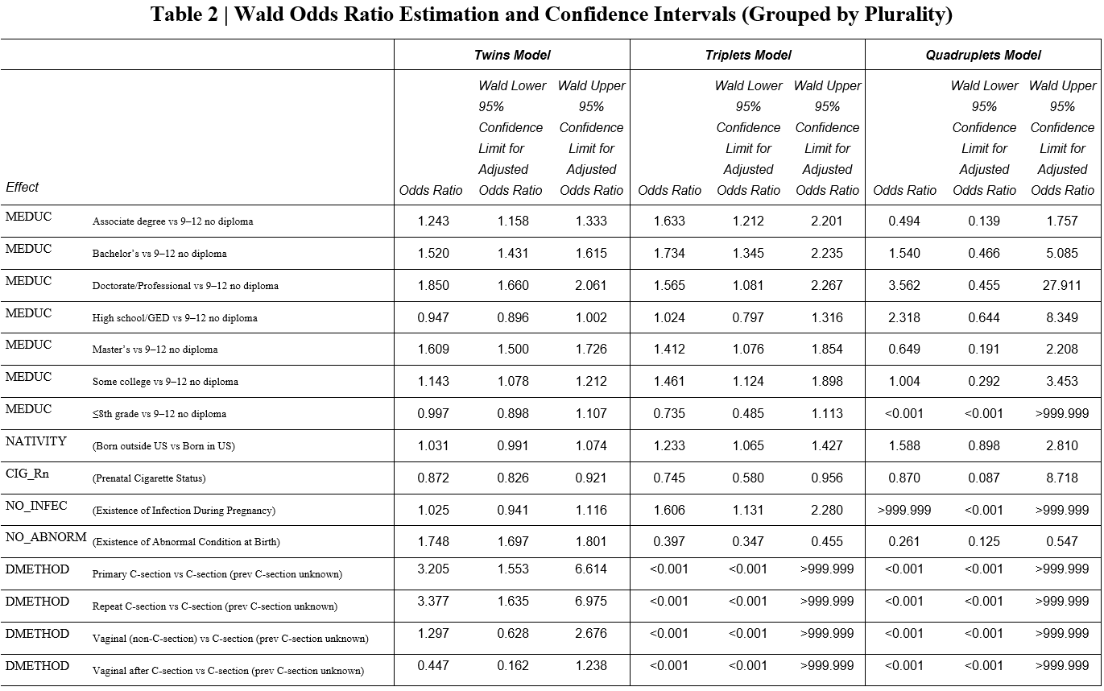
Table 2 summarizes how maternal and delivery factors affect survival. Education had a strong positive effect: for twins, mothers with bachelor's degrees were about times more likely to have all infants survive compared to those without a diploma, and similar effects appeared in triplets. In contrast, maternal smoking is significantly associated with lower survival odds across all models. Cesarean delivery had the larger positive effect, increasing the chance of survival two to threefold compared with vaginal delivery. Nativity and infection were not significant.
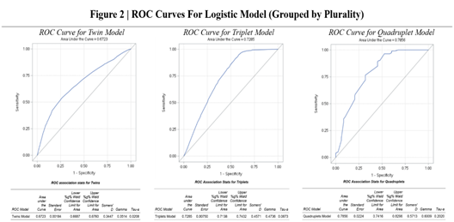Figure 2 illustrates the ROC curves for the logistic regression models stratified by plurality. The AUC increased as plurality increased, 0.67 for twins, 0.73 for triplets, and 0.79 for quadruplets, meaning the model was better at telling apart survivors from non-survivors in higher-order multiple births. Beyond the curves, the association statistics further confirm stronger predictive performance in higher-order multiples. Somers’ D, Gamma, and Tau-a all rise from twins to quadruplets, indicating better ranking of high- versus low-risk infants. The narrow 95% Wald confidence intervals across all plurality-specific models indicate that the predictive estimates are precise and highly stable.

These results show that behavioral and clinical factors strongly influence survival, while demographic characteristics, particularly maternal education, also play a meaningful role.

IV. CONCLUSIONS

From our analysis, maternal characteristics and perinatal conditions significantly influence survival outcomes in multiple gestations. Across twins, triplets, and quadruplets, higher maternal education consistently corresponded to greater odds of complete survival, while prenatal smoking was associated with reduced survival. We found that the existence of an abnormal condition substantially lowered survival, whereas a cesarean delivery notably improved survival outcomes and became nearly mandatory in higher-order pregnancies. Overall, both maternal characteristics and perinatal conditions are crucial factors in modelling birth outcomes in multiple birth events.

V. DISCUSSION

Few studies have applied statistical modeling to this dataset, with most existing work limited to descriptive summaries. Our analysis attempts to bridge this gap in knowledge by utilizing logistic regression to model how maternal and perinatal factors influence survival. We ended up utilizing a logistic regression model since all of our relevant variables were categorical.

Our findings indicate that higher maternal education and cesarean delivery are associated with more favorable birth outcomes, whereas adverse factors such as maternal smoking and abnormal conditions are linked to poorer outcomes. These patterns align with established biological and clinical expectations.

ACKNOWLEDGEMENTS | LIMITATIONS

The limitation of this study lies in the restricted access to fully continuous raw variables—many were available only as ordered categories—the absence of longitudinal follow-up beyond the one-year infant death linkage, and the exclusion of fetal losses before 20 weeks. Furthermore, there was a limit to publicly accessible metadata due to federal shutdowns leading to a non-response by the office: https://www.cdc.gov/nchs/nvss/mmb.htm. These factors constrain causal interpretability and narrow the spectrum of fetal deaths captured.

We once again acknowledge the National Center for Health Statistics (NCHS) and National Vital Statistics System (NVSS) initiatives for developing and documenting the dataset as well as the CDC for making the data publically accessible.

REFERENCES

- Fair Oaks Women’s Health. (2024). Your multiple gestation pregnancy [PDF]. Huntington Health.
- Huntington Health. (2024, September). Your multiple gestation pregnancy. https://www.huntingtonhealth.org/wp-content/uploads/2024/09/FOWH-Your-Multiple-Gestation-Pregnancy.pdf
- Centers for Disease Control and Prevention. (n.d.). Vital statistics online. National Center for Health Statistics. https://www.cdc.gov/nchs/data_access/vitalstat

Appendix

- Source Data File
Source of public data set and data dictionary: https://www.cdc.gov/nchs/data_access/vitalstatsonline.htm
- Raw dataset
- SAS dataset
- PROC CONTENTS output
- SAS Code

Additional Tabulated Tables (Referenced in SAS Code)
